DATA608 Knowledge and Visual Analytics (001)

Daniel Craig

9/10/23

# Executive Summary

## Topic: Infrastructure Investment & Jobs Act (IIJA) Allocation

#### Target Questions:

1. Is the allocation equitable based on the population of each of the States and Territories, or is bias apparent?

2. Does the allocation favor the political interests of the Biden administration?

**Table of Contents**

Executive Summary 1

Topic: Infrastructure Investment & Jobs Act (IIJA) Allocation 1

Target Questions: 1

Context: 2

Monetary/Infrastructure Summary: 2

Target Questions: 3

Trend Analysis 3

Geographical Analysis 6

Energy & Road 8

Conclusion 10

References & Code Appendix: 11

#### Context:

The Infrastructure Investment & Jobs Act (IIJA) was signed into law by President Biden on November 15th, 2021. This law encompasses the continuation of past infrastructure focused programs, as well as consolidates recently approved programs under one act. IIJA also expands on these past laws to further improve infrastructure in several areas (NCSL 2022). Much of the funding for the act was reportedly through savings by the government and helps resolve the issue of “donor” states to the Highway Trust Fund. The official document can be viewed here: [H.R.3684: Infrastructure Investment and Jobs Act | Congress.gov](https://www.congress.gov/bill/117th-congress/house-bill/3684)

List of previous acts/laws consolidated under IIJA:

* Fixing America’s Surface Transportation Act (FAST) – focused on funding US Department of Transportation for highway, vehicle safety, public transportation rail, research and more between the years of 2016 and 2020 (FHWA 2023)
* Surface Transportation Re-Authorization Act (STRA) – focused on improving and building roads, highways, and bridges (EPW2021)
* INVEST in America Act – Original name of IIJA before inclusions for broadband access, clean water, and electric grid renewal in addition to the original focus of transportation (NCSL 2022)

#### Monetary/Infrastructure Summary:

Total: $1.2 Trillion over 4 years

Summarized Breakdown of some larger items below. For full breakdown, please reference: [IIJA Guidebook from Whitehouse](https://gfoaorg.cdn.prismic.io/gfoaorg/0727aa5a-308f-4ef0-addf-140fd43acfb5_BUILDING-A-BETTER-AMERICA-V2.pdf)

|  |  |
| --- | --- |
| Public Transit: | $91 Billion |
| Rail: | $66 Billion |
| Bridges, Roads: | $60.5 Billion |
| Broadband Access and Affordability: | $57.7 Billion |
| Water/Sewage: | $48.7 Billion |
| Energy(Grid, Carbon, Hydrogen, Nuclear): | $35.5 Billion |
| Env. Remediation/Contaminants/Geo. Programs: | $32.7 Billion |
| State Formula Programs: | $26 Billion |
| Airports: | $25 Billion |
| Inland Waterways & Ports: | $14.5 Billion |
| Disaster Mitigation | $5 Billion |
| Cybersecurity: | $1 Billion |

(The Infrastructure 2021)

#### Target Questions:

1. Is the allocation equitable based on the population of each of the States and Territories, or is bias apparent?

2. Does the allocation favor the political interests of the Biden administration?

##### Trend Analysis

To begin answering these questions funding, population size, and geographical location will need to be evaluated.

The scatter plot below depicts the amount of funding provided to states, state population, and their party affiliation per the 2020 presidential elections (SOURCE: [What Are The Swing States Of The Future? | FiveThirtyEight](https://fivethirtyeight.com/features/what-are-the-swing-states-of-the-future/) ). Swing states are denoted in lighter colors, but labeled as their conventionally primary affiliation (SOURCE: [Swing States 2023 – Wisevoter](https://wisevoter.com/state-rankings/swing-states/)). A line of best fit is drawn to help highlight any deviations from the norm. It may be more accurate to show these pending the senator and governor political allegiance.

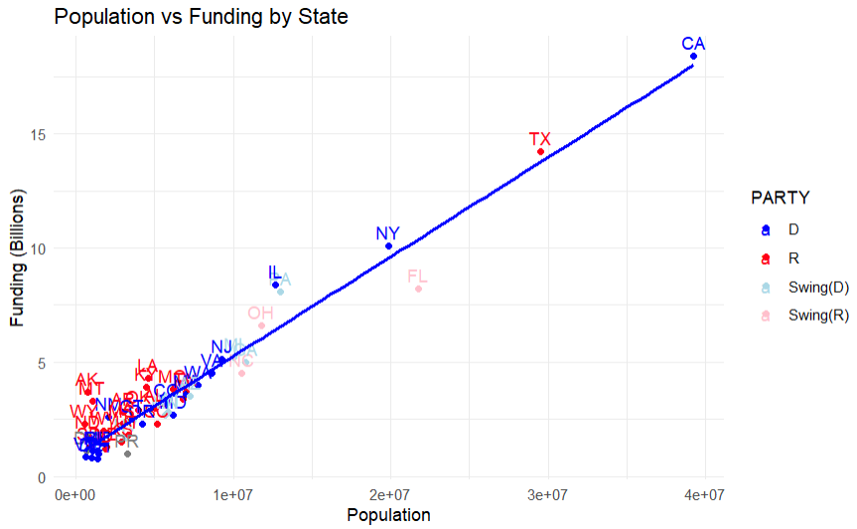

It’s clear there’s a relationship between the population and funding that a state received. Florida, Illinois, and Pennsylvania are distinctly far away from the line. Removing some of the more populous states reveals more.

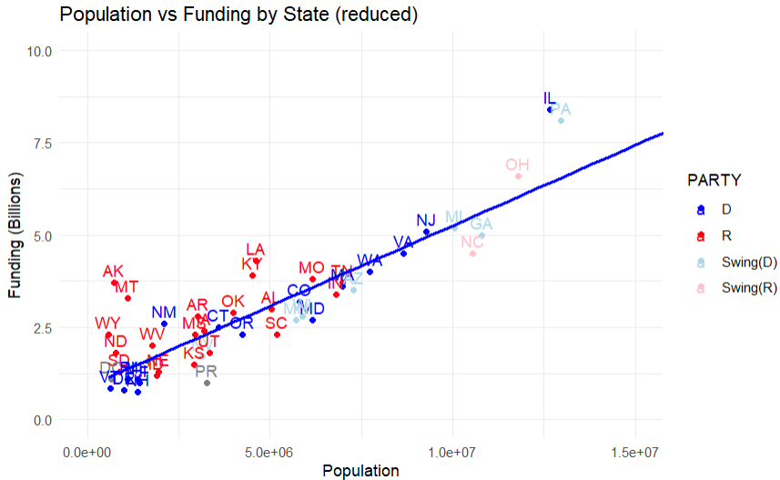This does show quite a few red states receiving quite a bit more funding than blue states. Notably though, most swing states seemed to have received less, which may seem counter intuitive if Biden was attempting to win votes. Arkansas and Montana also seem to be quite distant form the line.

Below is a plot of residuals to highlight the most distant states.

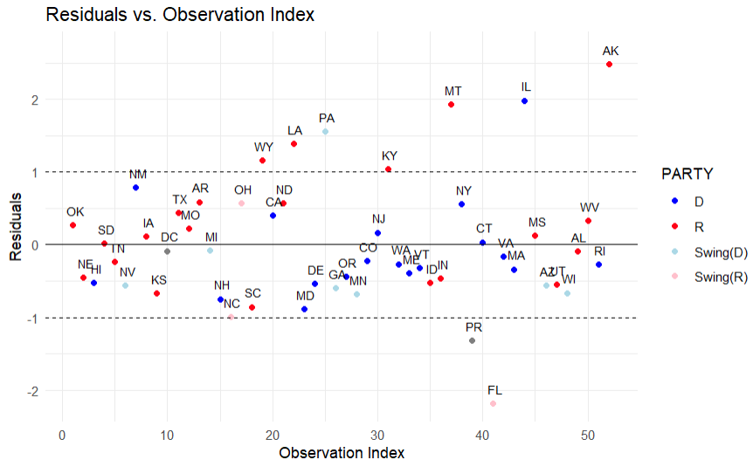

This highlights that Alaska, Illinois, and Montana are over-funded in relation to population and Florida is under-funded in relation to population. In this analysis, judgment is reserved for observations around 2 or more standard deviations from the norm as is typical when assessing for outliers. Less notable states being Pennsylvania, Louisiana, Wyoming, Kentucky, Puerto Rico, and Florida.

By observing these two plots, it would seem counter-intuitive that political scheming or bias is afoot. If there was, one would expect more swing states and Republican states to be receiving more aid.

##### Geographical Analysis

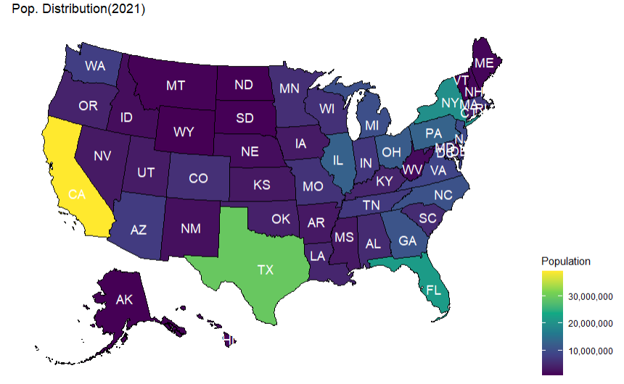

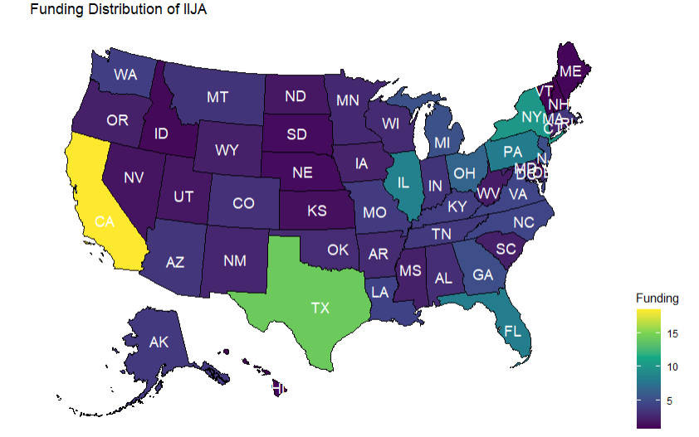

The population and funding maps are nearly identical, save for a few mid-western states.. Even our previously noted states (PA, AK, MT, IL, FL) do not appear abnormal.

If one graphs the states in relation to their residuals, our findings from earlier are highlighted. We can see MT, IL, AK, PA, LA, and FL all stand out.

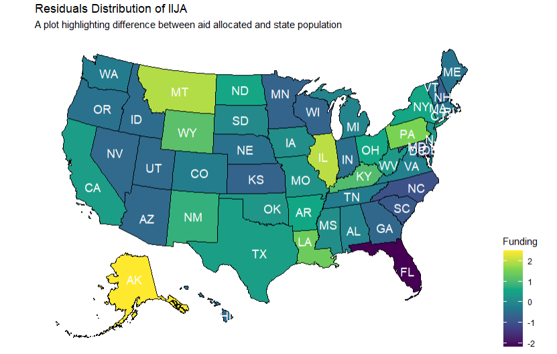

1. When accounting for geographic factors such as weather;

* Tornado Alley – outside of Illinois, there does not seem to be an over-distribution of funds
* Coastal – Coastal states do not have an apparent trend
* Region – Region tends to be associated with population, and also does not show a trend in residuals

##### Energy & Road

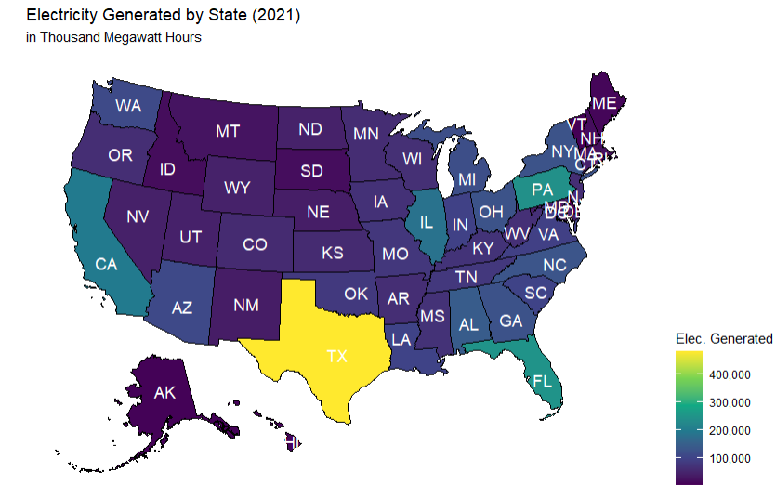

TX, PA, FL, CA, and IL lead the states in electricity generated. Both Pennsylvania and Illinois received more funding than their population would suggest, this may be the reason. It is surprising that Florida, despite being a notable contributor to electricity generation, and its history of natural disaster damage, would receive disparately low funding compared to other states.

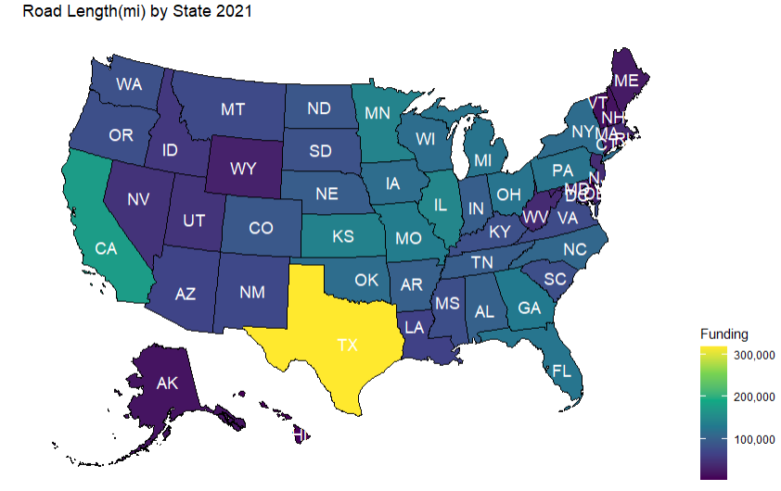

Although Texas and California lead in total road length owned by the state, the mid-west are brighter than most other regions. The darkness of the western states, barring California, supports the idea that road length is highly associated with population.

## ***Conclusion***

1. Is the allocation equitable based on the population of each of the States and Territories, or is bias apparent?

2. Does the allocation favor the political interests of the Biden administration?

After reviewing political allegiance, energy generation, and road length, political motivations seem unlikely to have played a factor when viewing political alignment based on presidential election by state. It may be more prudent to view political motivation by viewing Governor, Senate, and House political affiliations as they’re currently housed and IIJA had to be ratified by all government sectors.

Viewing the allocation of funding by population revealed the following states who received far more or less funding per their population:

|  |  |  |  |  |
| --- | --- | --- | --- | --- |
| Alaska(R)  + | Illinois(D)  + | Montana(R)  + | Pennsylvania (S)  + | Lousiana(R)  + |
| Wyoming(R)  + | Kentucky(R)  + | Puerto Rico(NA)  - | Florida(S)  - |  |

There is a clear correlation between population and energy generation but looking at each individually highlighted certain states of interest. In terms of population, it was clear that California, Texas, Florida, New York, and Illinois were among the most populous states. It is important to remember the breakdown of funding where Public Transit, Rail, Bridges & Roads, and Broadband received the largest allocations.

Viewing states by energy generation reveals that California, Texas, Florida, New York, and Pennsylvania were the nation’s most energy productive states in 2021, which correlates to their funding allocation, despite energy generation not being the most funded category of infrastructure. Road length revealed less. Roads heavily dominated Texas and California, once again, and showed a strong presence in mid-western states. It does not seem to have a correlation at first glance with funding. One could perform a correlation between funding directly, but seems unnecessary. It is important to note that Bridges & Roads were one of the most heavily allocated categories of infrastructure.

Further investigation into each State’s breakdown of the funding may reveal greater intentions. Political allegiance does not seem to have a place in the funding and seems more dependent on population. Some exceptions to this rule seem to be states that generate more electricity. The remaining unexplained states being Alaska, Montana, Wyoming, and Kentucky inexplicably have received more funding without relation to population or energy generation. The narrative to persuade these states as part of a political motivation would not be found in data. The last unexplained anomaly being Florida’s severe lack of funding per population and energy generation which would prove counter-point to any political motivations.

Most of the allocation of funding seems to be explained when accounting for energy generation and population. Remaining anomalies would find their reasoning, hopefully, in the sessions of Congress and its amendments to the original act.

#### References & Code Appendix:

[DATA608/Major Assignments/Story 1/Story1.Rmd at main · d-ev-craig/DATA608 (github.com)](https://github.com/d-ev-craig/DATA608/blob/main/Major Assignments/Story 1/Story1.Rmd)

NCSL. (2022). *Resource Infrastructure Investment and jobs act: Implementation and key resources*. National Conference of State Legislatures. https://www.ncsl.org/state-federal/infrastructure-investment-and-jobs-act-implementation-and-key-resources

*Fixing America’s Surface Transportation Act (FAST Act) - FHWA Operations*. (2023). Ops.fhwa.dot.gov. https://ops.fhwa.dot.gov/fastact/

‌

*EPW Committee Advances Surface Transportation Bill With Unanimous Support*. (2021). U.S. Senate Committee on Environment and Public Works. Retrieved September 9, 2023, from https://www.epw.senate.gov/public/index.cfm/2021/5/carper-and-capito-applaud-committee-passage-of-bipartisan-surface-transportation-bill

*The Infrastructure Investment and Jobs Act: An Explainer for States*. (2021). https://documents.ncsl.org/wwwncsl/State-Federal/NCSL_Infrastructure_Briefing_Nov22-Final.pdf

*Highway Statistics 2020 - Policy | Federal Highway Administration*. (2020). https://www.fhwa.dot.gov/policyinformation/statistics/2020/

‌*Electricity data browser*. (2021). https://www.eia.gov/electricity/data/browser/

‌